SHREYA MISHRA

Professor Name

AME 520 UNDERSTANDING ACTIVITY

05 December 2022

**COOKIE THE GOLDEN SACK**

***Abstract:*** Mocap has been of great importance since its invention. It has really made the job of artists in film industry much easier. Well, not just the film industry, it has even made the job of neuroscientists, therapists and all those people involved in the field of computer vision and robotics. But, this study relates to the use of mocap in generating simple as well as complex movements. It’s a well established fact that generating complex movements for characters designed is too complex and tedious job. So, to explore and generate movement of a 3D model of inanimate object, motion capture approach has been utilized in this study . A 3D model of flour sack has been created and motion capture file has been recorded. This work focuses on mapping the recorded human movement to the non-living rigged 3D model. This idea was an experiment in order to explore how successfully motion capture could assist in generating complex animated movements that too of non-human as well as non-living character. The 3D model of flour sack has been created and named as “Cookie the golden sack”. The experiment was successful but it could be further improved.

***Keywords :* *Motion capture, Rigging.***

**INTRODUCTION**

Since past, animation it has been great field of attraction especially in film industry. Since, then its has been evolved so greatly that its still used today. Be it any film, it requires use of advanced softwares, VFX editing and motion captures. Animating characters is one thing and mocap is other. The complex animation requires huge amount of time and it’s a tedious process. So, this process was made easy using mocap. Recording human movements and then mapping them to3d complex models seems much easier. There are various examples like planet of apes and Gollum in lord of the rings.

Generating complex characters without mocap is such a complex and tedious part. It requires full knowledge of neuroscience as well as physiology. Besides, predicting how the generated character could relate to the anatomy of human body is just too much. Though there are experts out in the industries who are really proficient at these type of tasks, still if some of the load is reduced using mocap , then it would be great.

The next section explains the motivation for the project and the following sections explain process and analysis of the project.

**MOTIVATION**

Though animators use motion capture recorded movements as a reference for their animations so that they could reproduce the same using their particular softwares. Still, the question arises how an inanimate object would react in case of movements when provided or applied the direct human recorded motivation. This question in itself is very interesting and intriguing. To answer this question, the 3D model of an inanimate object for instance, flour sack in this case was created. The mocap movement that was recorded was walking in different ways. The motivation for this study was simple question that has been stated above. For, this study mocap was recorded in the studio and 3D model was made using Blender.

***Motivation for Mocap***

For recording the mocap data, motive software was utilized in the mocap studio of Arizona State University. While creating different types of animation in entertainment industry, animators try to visualize how an inanimate object would display each type of human movement in it’s own simple way. While recording this movement, I thought of similar movements but it’s difficult to capture these types of movements while performing motion capture. So, for my recording, I performed simple walking for approximately one and a half minute The movements were simple though not that simple . I imagined a square and walked along the edges of the square. I also walked diagonally, in reverse direction and in slow motion. While walking in forward direction the, the speed of the movements was quite fast as our human brain regularly deals with these types of movements. Walking in reverse direction was simple as compared to walking with long-steps(slow-motion) in horizontal direction. The tempo while recording these steps was slow as brain was trying to get acquainted with these types of movements. Wile walking with crossed legs was super fun and it had a great tempo. I was trying to recall many other movements while recording.

***Motivation for Character***

I choose flour sack as an inanimate object for this project. Well there was no specific reason for choosing this object. While learning animation , pose and figure drawing, the simplest example till date is of flour sack. Even the book by Richard Williams, “ Animators Survival Kit” mentions it. Even today if one can generated gestures with flour sack texture, then it’s considered good. Though generating animation using keyframe is quite different rather then just mapping the movements of recorded movement to the 3D character, so I considered basic object i.e. flour sack for my project. I designed a character cookie (the flour sack). Initially, there was not any story in mind But, later I wrote a script for this character.

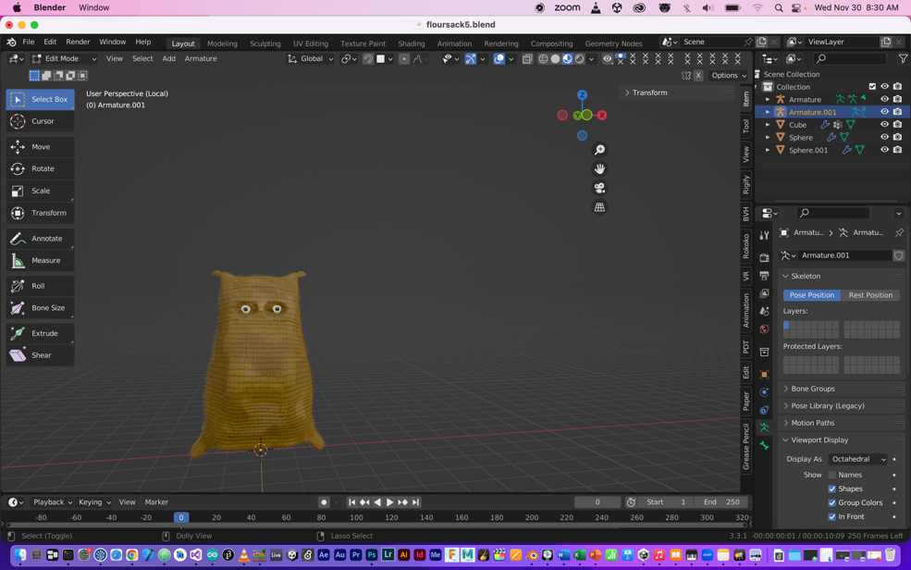

**Fig. 1 Front View of the Character**

The image above describes the front view of the character I designed. The above image is of non-rigged character. The image below describes the dorsal view of the character.

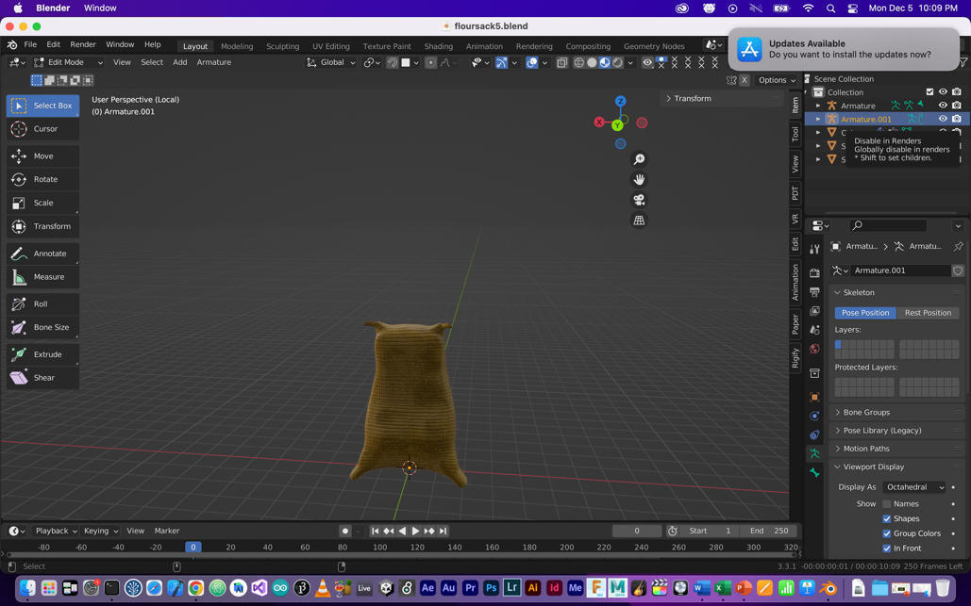

**Fig. 2 Dorsal View of Cookie the Sack**

***Cookie’s Story***

It’s hard to survive in this world especially without learning anything. You need to learn everything since childhood. When a baby is born, he /she at that doesn’t know anything even walking. It takes one to two year for him/her to walk properly. His brain needs to get adapted to that. In short humans are good at these types of movements because they are practicing them since long time.

Now, consider what will happen if a non-living thing out of the blue aspires to walk. We don’t know that thing has a brain or not, since it started walking ; it’s just the matter of point of view. What would be the consequences if this non-living thing tries to imitate in human world while copying there movements.

The story starts in a warehouse where the flour sack is lying since months at the same place. Suddenly he feels something, that he is bored of being lying down at the same place. He decides to explore this wicked world all by himself . But, he is scared as he really doesn’t know anything about this world. So first he tries to walk in the warehouse by himself like I was walking in the mocap studio. He is trying to walking the edges of the squared tiles in the ware house.

In this project, an attempt has been made to render this movement as an animated video.

**RESEARCH GOAL**

Well research goal was to explore the movements that non-living objects could follow, using motion capture.

**PROCESS**

The steps followed could be listed in the following manner.

***Step 1***

First the motion capture was recorded in the mocap studio.

***Step 2***

The 3D model of cookie was created. Fig.3 describes non-textured 3d model of cookie.

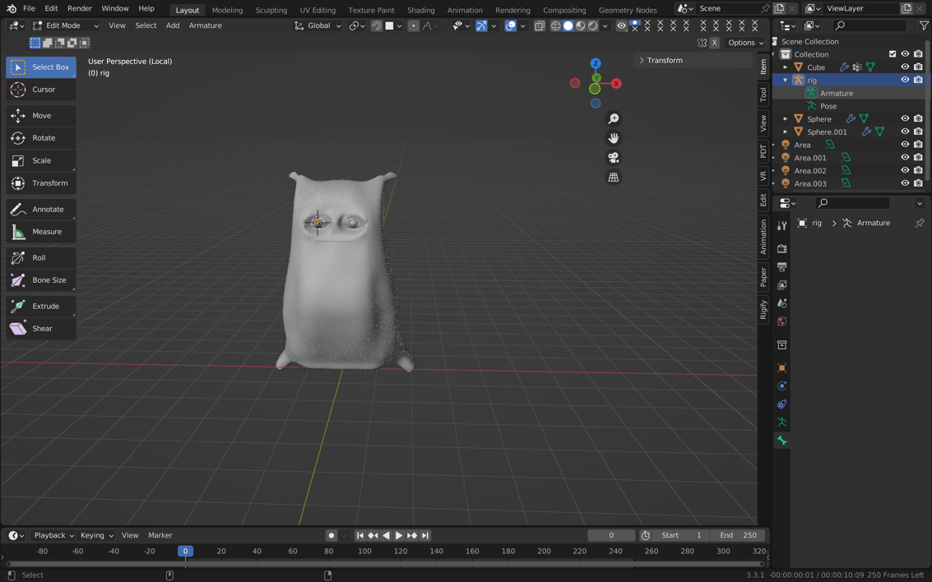

**Fig.3 3D Model of Cookie**

***Step 3***

This step is UV Unwrapping. The UV of whole model is unwrapped so that it could be shaded and textured after that. The image below, describes the UV Unwrapping of the model.

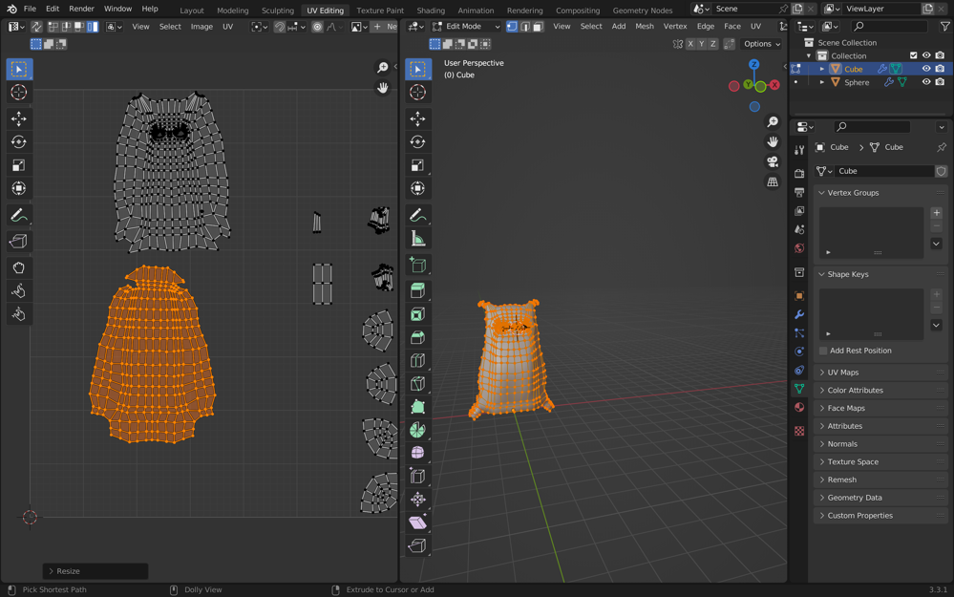

**Fig.4 UV Unwrapping**

***Step 4***

The 3 D model was given a texture. Since there was lack of proper textured images of flour sack so, I created the texture for the sack as well as for eyes and then applied it to the model. The figure 5 describes the cloth texture for the sack bag. It is grey in color, various shading nodes were applied in blender to produce the yellow color. The figure number six describes the eye texture for the sack bag. The final textured images of the model are described by figures 1 and 2.

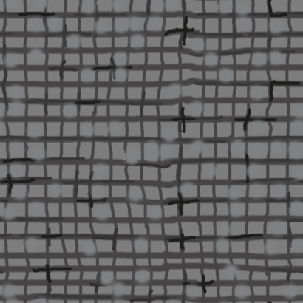

**Fig.5 Texture of the sack**

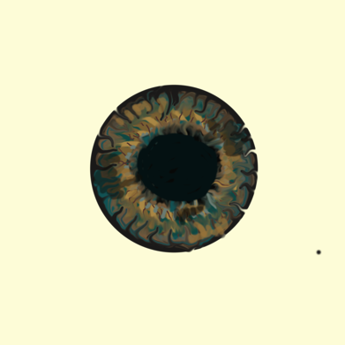

**Fig.6 Eye Texture**

***Step 5***

This was most important steps of all. In this step, model was rigged. Rigging means creating skeleton for the mesh of the 3D model and then combining bot h mesh and skeleton together. When we generate movements using skeleton, the mesh follows it. It was an important step because the rigging determines the quality of movement of the character. Since, the character is non-human so, I created a different rig (bone structure) for it. I also applied the human armature to the 3D model to see the difference in the quality of movements. The figure 7 describes the rigged model of the character. This is the bone structure that I provided to the character. I added ears in order to move the upper part of the body. I also added the controls for ears and eyes and used a root bone to control the spine and the legs. I did this so that character could be animated using key frame also, in case if one doesn’t want to retarget it. I made head as the parent bone for shoulders, hands, upper and lower arms and for ears. Made hips as parent bone for spines , head, neck , root bone and legs. I used the concept of bendy bones for this. They could squash and stretch easily, and they require one control bone. Since the bendy bone option in blender is not that effective so I manually created bendy bones. I did this so that the moving sack could look like a sack and not as a rigid body.

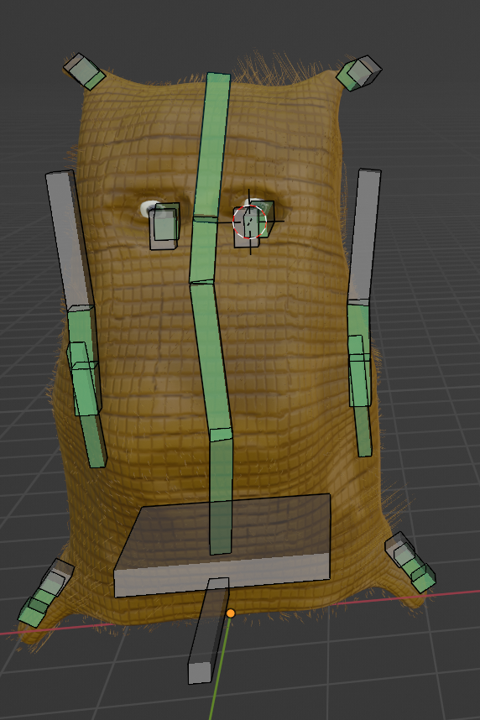

Eye Control

Eye

Spine

Right Foot

Spine 1

Hand

Left Lower Arm

Neck

Left Upper Arm

Left Shoulder

Head

Right Ear

Left Ear

Right Ear Control Bone

Left Ear Control Bone

**Fig. 7 Rigged Model**

Right Lower Leg

Right Upper leg

Hips

Root Bone

Though the sack doesn’t have hands, still I have created the bones so that his waist and side part could move and give a proper movement to whole sack movement. The movement of head and spines could complement his whole body movement. I also rigged this character with human skeleton. The figure 8 describes the rigged model with human skeleton.

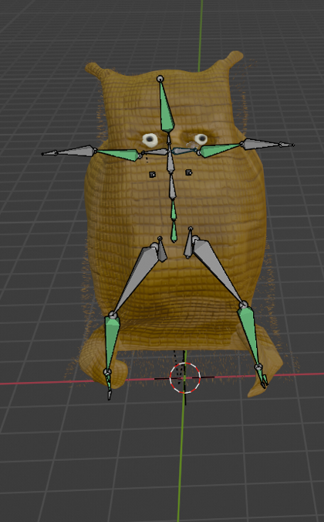

**Fig.8 Another Rigged Model**

I applied human armature to the model and then combined them.

***Step 5***

This step is called retargeting. Retargeting is the process of transferring movements from mocap data to the 3D rigged model. The mocap data that I recorded was in the form of bvh file. Retargeting is easy when the both the files rigged model and the bvh file are in human skeleton form and have same bone structure. In that case addons as rokoko could be used but for this case I manually added the bone constraints. Copying all the transforms of bvh file wasn’t working in my case, as the character doesn’t have human skeleton. I copied only rotations of the bvh file to my character and that too I didn’t copied the corresponding rotations I mixed and matched the rotations. Because applying corresponding rotations to each bone from bvh to the 3D model went awry. I only mapped few bones and not all.

***Mapping***

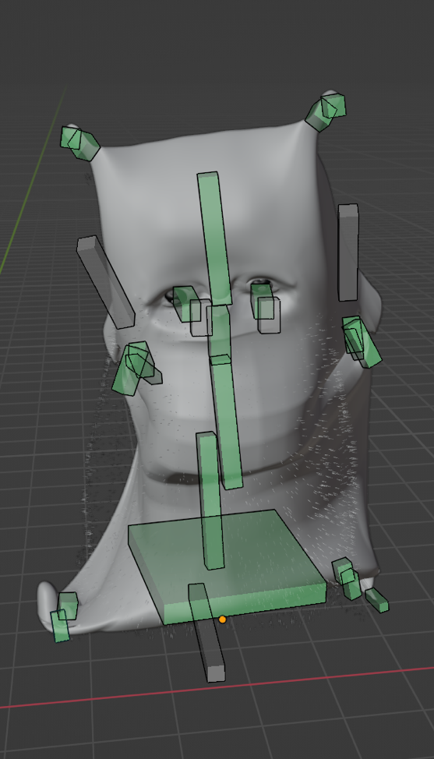 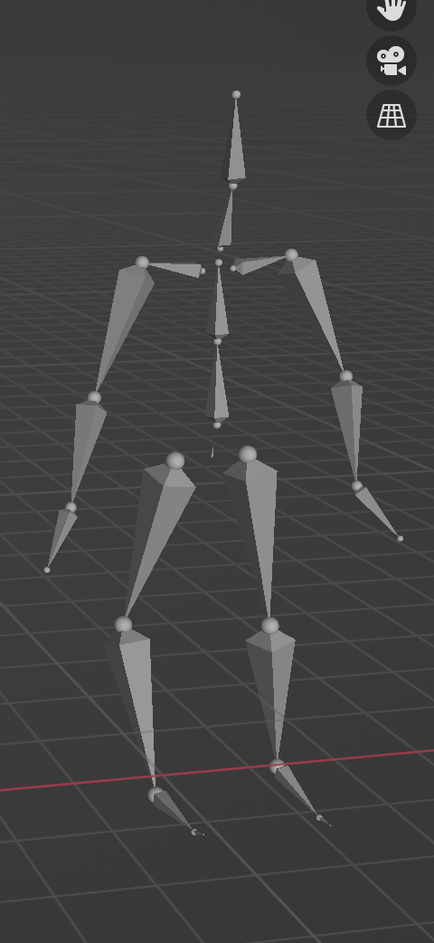

**Fig. 9 Retargeted Model Fig. 10 BVH File**

**HEAD BONE = HEAD BONE**

**SPINE = SPINE**

**RIGHT EAR CONTROL = RIGHT SHOULDER**

**LEFT EAR CONTROL = LEFT SHOULDER**

**HIPS = HIPS**

**LEFT UP LEG = LEFT UP LEG**

***Mapping***

**RETARGETED MODEL BVH FILE**

**RIGHT UP LEG = RIGHT UP LEG**

**LEFT TOE = LEFT TOE BASE**

**RIGHT TOE = RIGHT TOE BASE**

I assigned shoulder rotation values of bvh file to the ear controls of the 3D model because I wanted to behave them like shoulders. With the movement of ear controls, ears will also move. Consider the case of second rigged model.

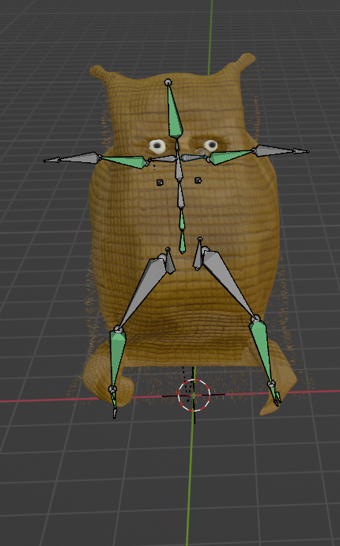 

**Fig. 11 Retargeted Model Fig. 12 BVH File**

**HEAD = HEAD**

**RIGHT UPPER ARM = RIGHT SHOULDER**

***Mapping***

**RETARGETED MODEL = BVH FILE**

**LEFT UPPER ARM = LEFT SHOULDER**

**LEFT LOWER LEG = LEFT UPPER LEG**

**RIGHT LOWER LEG = RIGHT UPPER LEG**

**RIGHT HEEL = RIGHT FOOT**

**LEFT HEEL = LEFT FOOT**

**SPINE = SPINE**

**HIPS = HIPS**

I mixed and match the mapping to get the best movement quality from 3D model.

**OUTCOME**

The character cookie was rotating when mapped with the bvh file. Here are the some screenshots that have been taken while the character was rotating.

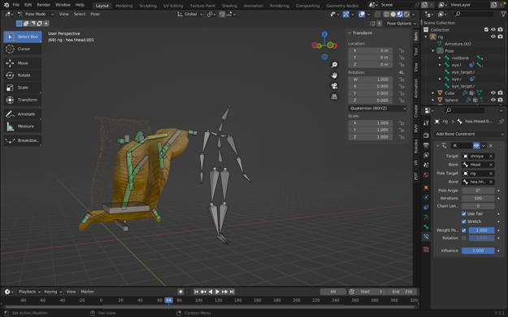

**Fig. 13 Random Image**

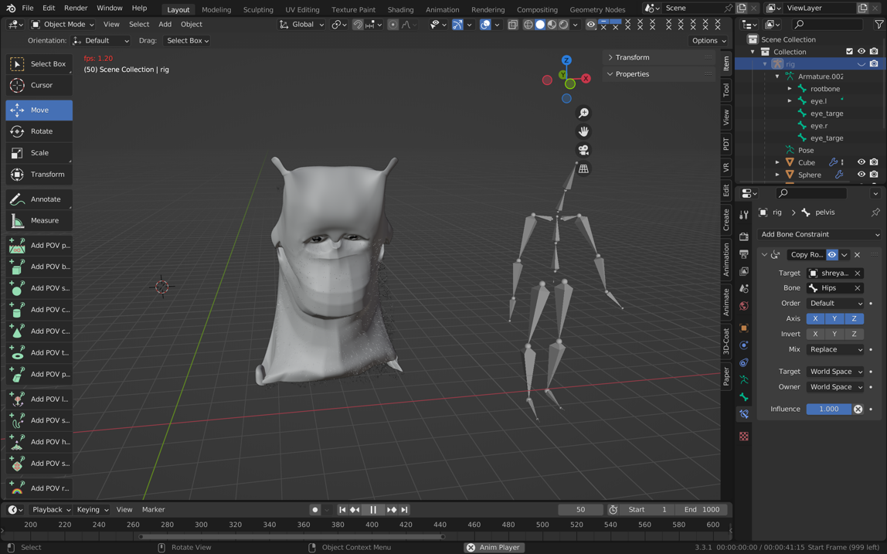

**Fig. 14 Random Image**

**USAGE**

This is a sort of character model and when once uploaded on platforms like git hub , then it could be used by others for various purposes. It is also an example of retargeted motion capture into non-living 3D model. One could retarget their mocap into this and can generate different types of movements.

**DESIGN GAP**

I was trying to generate a type of motion so my character could walk like the bvh file. But, that is not possible because I haven’t copied the location transformations of the bvh file to the 3D model. That was a huge design gap as I was not able to see the actual consequences of what I was trying to achieve. I thought retargeting would be easy but it is much more complex than I had thought. I was able to rotate my character because I mismatched the bone mapping for the two models. I was trying to create a scared character and I created a funny rotating character. The question remains unanswered that how my character would explore the world if he is not able even walk. I will try to solve this issue in future. But, I’m not sure will it be solved or not .

**FUTURE SCOPE**

I would try to improve the quality of movement of character by improving the rig and trying other bone constraint options. In future , this idea can be applied to other non-living objects as well.

**CLASS DISCUSSIONS**

The class discussions and especially readings were of great help. I was able to mix and match the bones because I knew the function of each bone science behind. The knowledge of how a simple short movement would effect the anatomy of the body is really beneficial while creating animations. They provide direction as well scale for generating character models and there animations. Sometimes it is impossible to figure out what you are missing in your work, so it’s better to take other point of views. This gives a sense of accepting and understanding other’s point of views and helps you in understanding team work. The class discussions and workshops really assisted me in improving my skills and knowledge in particular subject.

Movement studies really helped in shaping creativity. Because they provide new insight of thinking. Somatics is really helpful in understanding a lot about mind- body connection. Well consider the case of this project, it requires a lot of brainstorming on how to make an object move according to your imagination while maintaining its movement quality. It is somewhat related to philosophy and gives a direction to think differently, philosophically and creatively.

**CONCLUSION**

Generating movements is in itself a complex task and imagining those movements for non-human and non-living characters is in itself a complex task. Also, recording mocap while imagining imaginary movements that brain is not used to, is too challenging. Although it helps in shaping creativity but it is still not an easy to do task. The task of this study was achieved but not fully as the character is rotating and moving at the same place. Improvements will be made to it in the near future.

**FEEDBACK FROM CLASS**

The presentation that I gave lacked video submissions, so I presented the movements in the blender and the movements generated in the blender were quite slow. Well there were some rendering issues but that are solved now.